196 Main Street, New Paltz, New York 12561 • Phone: (845)256-4100 • Fax: (845)256-4109 • www.newpaltz.k12.ny.us

Dr. Samuelle Simms Kathleen Schneck
Principal Assistant Principal

To: Advanced Drawing and Painting Students
From: Mrs. Laurene Pountain
Date: June 12, 2023

It has come to my attention that you have elected to enroll in Advanced Drawing and Painting for the 2023-2024 school year. The class is offered as a full year, advanced elective course. This course is designed to prepare students and their portfolios for a future in art. There will be much focus on portfolio development and college preparation. I wanted to take this opportunity to give you an idea of what will be expected and to alert you to the summer homework.
Class Overview:
- Throughout the year we will study various artists and trends, both historical and current. We will visit galleries and museums. You are also encouraged to visit and explore on your own.
- We will address individual portfolio needs and preparation. Visits to college portfolio days will be arranged.
- Regular in class critiques will be held. Students are expected to use open studio hours to assure completion of work for critique.
- I suggest that you begin an artist “toolbox”, if you have not already. The Art Department has general supplies available, however when you are working at home it may be useful to have some of your own.
  - Suggested Materials:
    - Portfolio or Large folder to transport work to and from school
    - Watercolors and Brushes (you may want acrylics and brushes as well)
    - Graphite Pencils of varying hardness (4h thru 6b)
    - Pastels and/or Charcoal
    - Erasers (kneaded, gum etc.)
    - Sharpie markers (varied thickness)

*These are suggested materials. They are not required. Any material brought to school should have a name on it. Don’t forget to ask for student discounts and look for coupons!
- A sketchbook will be required and you will be expected to work regularly in it. Compiling sketches, ideas, photos, techniques, plans etc. Many colleges require an artist notebook along with a portfolio. It is also good practice in general, as an artist.
- Homework will be given regularly. You should be accustomed to this practice from Drawing and Painting. Pieces are expected to be complete, portfolio quality, works.
SUMMER HOMEWORK – due the first day of class for critique (minimum size - 9” x 12” each)
* Note this should be portfolio quality work. These pieces will be hung for display.
“Take a Perspective Journey”

Do a series of observational (small scale) drawings/studies in your sketchbook (5 or more) that construct a sequential passage from outdoors to indoors (or vice versa). To ensure a sense of movement through space, select views that make a strong transition from wide open space to middle ground to close-up space.

Choose 3 of these studies to be executed as full scale drawings (pencil, colored pencil, pen and ink etc.). Each of these should have something in it that connects it formally or symbolically to the next piece. For instance, an object or texture may appear in several drawings, or an underlying structural rhythm may connect the whole sequence.

You may be interpretive with your final pieces in order to help create the sequence. A journey through the environment consists of not only what you see (land, architecture, objects) but also what you sense and feel. The feeling is what will help you move through the images.
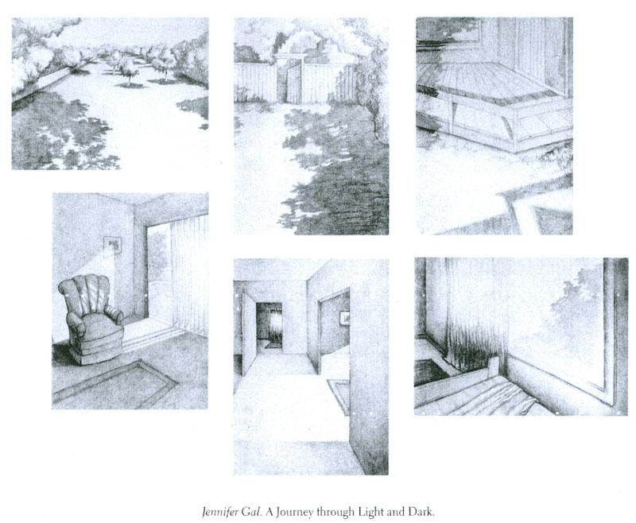
* There are additional examples on my website.
I hope you are enjoying your summer and looking forward to the school year ahead. If you have any questions, I can be reached via e-mail at lpountain@newpaltz.k12.ny.us
See you in September!

Sincerely,

Laurene A. Pountain
Art Teacher - New Paltz High School

